Business Canvas Project Components
Business Name: DiabetesCare
Team Members: Angad, Abhay
Tagline: The diabetes app that grows up with you.
Customer
*Identification and verification of customer problem, need, or want (Unit 1)
- Quick background: with type 1 diabetes, the body stops making insulin, the hormone that controls blood sugar. People have to check their sugar and give themselves insulin every day for the rest of their lives. It usually starts in childhood.
- For a young child, the parents do all of this work. Around the teenage years, the kid is expected to take over, and that switch often happens suddenly with no plan.
- It shows. A national study of about 22,700 patients found that blood sugar control is worst between ages 15 and 18, and only 17% of kids and teens reach their blood sugar goal (Foster et al., 2019).
- Parents are stretched too. In one study, parents said being able to check their child's numbers from their phone gave them confidence, but it also meant they never got a break (Hart et al., 2022).
- Some apps for kids exist, and so do apps for adults. What's missing is one app that follows a child from the years when a parent is in charge all the way to managing it alone.
- Next step to confirm the problem: talk to 10 families and survey 50 people (see Research findings below).
*Target customer profile (2)
- Main buyer: a parent of a child or teen with type 1 diabetes. Example: Maria, 41, lives in Katy. Her 10-year-old son was diagnosed at 7. She checks his sugar at night, texts the school nurse every day, and is nervous about him starting middle school. She would pay for anything that helps her sleep.
- Main user: the teen. Example: Jordan, 15. He wants his parents to stop nagging and skips tracking when it feels like homework. He will use an app that looks and feels like a normal teen app.
- Second market: adults with type 1 diabetes who want everything in one place. Today's teen users grow into this group.
- Size: about 2.1 million Americans have type 1 diabetes. About 314,000 are under 20 (where we start) and about 1.8 million are adults (where we grow). Source: CDC.
Plan to build customer relationships, including sales tactic(s) (2)
- Free to download, with a free 30-day trial of the family plan. No credit card needed to try it.
- Each family plan lets parents invite up to four other caregivers, like grandparents or a coach, at no extra cost. Every invite introduces the app to another household.
- School nurses always use it for free. When a nurse likes it, she tells the other diabetes families at her school.
- We show up in person at diabetes camps and at local events run by Breakthrough T1D, the largest type 1 diabetes charity.
- We answer every piece of feedback within two days and send users a short monthly update on what we fixed.
*Research findings on customer preferences (2)
- What published research already tells us:
  - Parents like seeing their child's numbers from anywhere, but they also want to be able to hand off and rest. So DiabetesCare lets parents take turns being "on call."
  - More and more kids wear a small sensor that reads their blood sugar automatically. Our app pulls in those readings, so nobody has to type them in.
  - Reviews of the top-rated competitor praise two things: sharing with family and fewer annoying alerts. We treat both as must-haves.
- Our own survey (planned, results coming): we will survey 50 people, a mix of parents, teens, and adults with diabetes, through school nurses, local diabetes groups, and camps. We will also interview 5 parents and 5 teens.
  - We will ask: Which apps do you use now, and what bugs you about them? Who handles the diabetes care, you or your child? At what age should a kid take over? Would you pay $40 a year for a family plan? Which features matter most?
*Marketing campaign, including digital marketing tools (2)
- Campaign name: "Grows With You." We launch in November, which is Diabetes Awareness Month, and push again in August when parents set up care plans for the new school year.
- Instagram and TikTok: short videos made by us, like "a school day with diabetes" and side-by-side looks at the kid and teen versions. We design posts in Canva.
- A simple website with an email sign-up list (Mailchimp) for early testers.
- Paid ads in the App Store for searches like "diabetes app for kids."
- Referral codes and tracking links, so we can see which posts and ads actually bring in users.
Key performance indicators (KPIs) for customer-related goals (4)
Goal | What we measure | Target
Confirm the problem | Interviews and survey responses | 10 interviews, 50 surveys before launch
Keep users | Users still active after 30 days | At least 40%
Turn users into buyers | Free users who start paying | At least 6% in Year 1
Word of mouth | Caregivers invited per family | At least 1.5
Happy customers | App Store rating | 4.5 stars or higher

Product (Good or Service)
*Product idea that achieves a problem-solution fit (1)
- DiabetesCare is an iPhone app for tracking blood sugar, insulin, and meals, with three versions that the user moves through as they grow up:
  - Kid version: parents are in charge. Big buttons, a friendly mascot, rewards, and alerts sent to parents. The school nurse can see it too.
  - Teen version: the teen does the tracking and parents can still see it. As the teen shows they can stay on top of it, they earn more control and parents get fewer alerts.
  - Adult version: all the tools, plus a one-tap report to bring to doctor visits.
- Why it fits the problem: the hard part is the handoff from parent to child, and families today have to switch apps and lose their history to make it. With DiabetesCare, they keep one app and one history, and the handoff happens step by step.
*Minimum Viable Product (MVP) used to assess product-market fit (2)
- Angad has already built a working version of the app that handles tracking, reminders, charts, and doctor reports.
- For the MVP we are adding the kid and teen versions and the ability for parents to follow along from their own phones.
- We will give it to 10 to 15 local families for four weeks.
- We will know it works if most families keep using it every week, if at least 40% of parents say they would be "very disappointed" to lose it, and if at least 5 families offer to pay early.
Value proposition (2)
- For families raising a child with type 1 diabetes, DiabetesCare is the one app that grows up with your child. Parents are in control while kids are young, teens earn independence, and adults get the full set of tools. The family never has to switch apps or start over.
*Branding/brand identity (2)
- Name: DiabetesCare. Tagline: "The diabetes app that grows up with you."
- Colors: calm teal for trust and warm coral for energy. The kid version has a friendly mascot, and the adult version looks clean and simple.
- Tone: encouraging, never guilt-tripping. The app says "Nice streak!" and never says "You missed 3 check-ins."
- One risk: a well-known medical journal is also called "Diabetes Care." We will check trademarks before launch and have backup names ready.
Organization
Vision statement (1)
- A world where every kid with diabetes grows up confident taking care of themselves.
Mission statement (1)
- DiabetesCare gives families one simple app to track diabetes, and helps parents hand control to their kids at the right pace.
Skills assessment (4)
Skill we need | Why | Who has it | Plan if missing
Building apps | Make and update the product | Angad (built the current app) | Covered
Data and research | Track results, study customers | Angad (university research experience) | Covered
[Abhay: add strengths] | [e.g., marketing, design, finance] | Abhay | Covered
Medical knowledge | Make sure the advice is safe | Neither of us | Recruit a diabetes nurse educator as an advisor
Privacy law | Rules for apps used by children | Neither of us | Use a standard template, pay for one lawyer review
Art and design | Logo, mascot, kid version | Some | Canva plus a freelance artist
Strategy decision using the PACED model (4)
- Problem: Which customers should we go after first?
- Alternatives: (A) adults with type 1 diabetes only, (B) everyone who takes insulin, or (C) kids and teens with their parents, with an adult version too.
- Criteria and Evaluation: we scored each option from 1 to 5.
What matters (weight) | A: Adults only | B: Everyone who uses insulin | C: Kids and teens with parents, plus adults
Fits the app we already built (30%) | 5 | 3 | 4
Fewer competitors (25%) | 2 | 2 | 4
Easy for us to reach and interview (20%) | 2 | 2 | 5
Customers willing to pay (15%) | 3 | 3 | 4
Little extra work to build (10%) | 5 | 3 | 3
Weighted score | 3.35 | 2.55 | 4.10
- Decision: Option C. It has the fewest competitors and the clearest problem. As students, we can easily reach families at school and camps, and parents are motivated to pay. The adult version lets us grow later.
Operations
Supply chain plan, including process(es) for producing the good or service (1)
- We sell an app, so there is no factory or inventory. What we depend on: Apple (to build and sell the app), the companies that make blood sugar sensors (their readings flow into the iPhone), a diabetes nurse educator (to check our advice), and a freelance artist.
- How we make it: every two weeks we pick the top requests from users, build them, test them with a small group of families, and release an update.
- How customers get it: they download it from the App Store.
- How we handle problems: feedback goes into a weekly list, and anything affecting safety, like a missed alert, gets fixed first.
Marketing channel (2)
- Main channel: we sell directly to families through the Apple App Store. Apple keeps 15% of each sale.
- Referrals: school nurses, diabetes educators, children's diabetes clinics, and diabetes camps point families to us.
- Later: we could sell a version to school districts and clinics.
KPIs for operations-related goals (4)
Goal | What we measure | Target
Reliable app | Share of sessions with no crash | 99.5% or more
Keep improving | How often we release updates | Every 2 weeks
Safety first | Time to fix a safety problem | 2 days or less
Good support | Time to answer feedback | 2 days or less

Market
Plan to seek competitive advantage (1)
- We will win by being different, not by being the cheapest. We are the only app that grows from a kid version to a teen version to an adult version, and we give school nurses free access.
- We are teenagers ourselves, and we build the teen version with teen testers, so it doesn't feel like a medical chart.
- We don't pay salaries, so our costs stay low and we can charge less than or the same as competitors.
- Once a family has years of history and their whole care team in the app, they are unlikely to leave.
PESTEL Analysis (1)
Factor | What's happening | What it means for us
Political | The government lightly regulates apps that only track health info. Apps that tell you how much medicine to take need government approval. | We track, we don't tell people how much insulin to take. That keeps us out of the approval process.
Economic | Diabetes is expensive for families. Insulin and supplies already cost a lot. | Keep a strong free version and a low yearly price.
Social | Teens struggle most with diabetes. Parents lose sleep worrying. Some kids feel embarrassed at school. | Make it fun for teens and calming for parents.
Technological | More kids wear sensors that read blood sugar automatically, and phones can collect those readings. | Pull readings in automatically so nobody has to type them.
Environmental | An app has very little environmental impact and replaces paper logbooks. | Small factor. We can mention "paperless" in marketing.
Legal | A federal law (COPPA) requires parent permission before collecting information from kids under 13. The rules got stricter in 2025. | Parents set up the kid accounts. We never sell data or show ads.
Research findings on competitive landscape (2)
Competitor | Who it's for | Price | What it's missing
mySugr | Adults; has a cartoon monster to make tracking fun | Free, or $2.99 a month | No way to hand off from parent to child
Gluroo | Families sharing a child's data | Free (4.7 stars on the App Store) | Kids and adults get the same app
Happy Bob | Anyone who wants rewards for good habits | Free | Fun, but has few tracking tools
BlueLoop | Parents, school nurses, and doctors | Free | Kids outgrow it
Sensor and pump company apps | People using that company's device | Free with the device | Only show one device's data
KPIs for market-related goals (4)
Goal | What we measure | Target
Local start | Downloads in the Houston area, first 3 months | 500
Partners | Camps, clinics, charities, and nurse groups working with us | 3 in Year 1
Get found | Ranking when people search "diabetes app for kids" | Top 10
Market share | Paying families out of 314,000 US kids and teens with type 1 | 900 families by end of Year 2
Framework analysis of market using Porter's Five Forces and/or SWOT Analysis (4)
Porter's Five Forces
Force | Strength | Why
Rivalry among competitors | High | Lots of free apps, some from big companies
New competitors entering | Medium to high | Apps are cheap to make, but earning parents' trust is hard
Substitutes | Medium | Paper logbooks, group texts, device apps
Power of buyers | High | Free options exist and families can switch easily at first
Power of suppliers | Medium to high | We rely on Apple and on sensor companies sharing their data
SWOT
Strengths | Weaknesses
The app already works. No one else offers a kid-to-teen-to-adult app. Our costs are low, and we are close in age to our teen users. | No medical expert on the team yet. iPhone only. No survey results yet. Possible trademark conflict with the name.
Opportunities | Threats
Launching during Diabetes Awareness Month. School nurses can spread the word for free. More kids are using blood sugar sensors. We could sell to schools and clinics later. | A bigger competitor could copy the idea. Children's privacy rules add cost. Sensor companies could limit data sharing.

Finance/Accounting
*Projected pricing strategy (2)
- The basic app is free, and people pay for extra features. Our prices are close to competitors'.
Plan | Price | What you get
Free | $0 | Basic tracking, reminders, 30 days of history
Plus (adults) | $2.99 a month or $24.99 a year | Full history, trends, doctor reports
Family | $4.99 a month or $39.99 a year | Everything in Plus, the kid and teen versions, and up to 4 caregivers
- Plus costs about the same as mySugr's paid plan. Family costs $15 more a year and includes features no competitor has. The yearly plans save about 30%, and school nurses always use it for free.
Startup costs (3)
Item | Cost
Apple developer account (1 year) | $99
Website name | $15
Online storage for user data (1 year) | $120
Lawyer review of privacy policy | $600
Payment to diabetes nurse advisor | $400
Logo, mascot, and artwork | $350
Launch ads (social media and App Store) | $500
Event booths, flyers, and cards | $250
Used iPhone for testing | $200
Extra cushion (10%) | $253
Total | $2,787
Potential source(s) of financial capital (3)
- Our own savings will cover the first $1,000 or so.
- Student pitch competitions and grants, like the Diamond Challenge, the Conrad Challenge, and local business competitions.
- Crowdfunding from the diabetes community during Diabetes Awareness Month.
- Later, once families are paying, we can apply to health startup programs and to investors focused on diabetes.
Revenue projection (3)
- We assume 6 out of 10 paying customers choose Family ($39.99) and 4 out of 10 choose Plus ($24.99), so the average customer pays about $34 a year. Apple keeps 15%. Customers join throughout the year, so we base revenue on the average number of customers during each year.
 | Year 1 | Year 2 | Year 3
Paying customers by end of year | 150 | 900 | 3,000
Average paying customers | 75 | 525 | 1,950
Total sales | $2,549 | $17,845 | $66,280
Sales after Apple's cut | $2,167 | $15,168 | $56,338
KPIs for finance-related goals (4)
Goal | What we measure | Target
Stop losing money | When yearly profit turns positive | During Year 2
Spend wisely | Marketing cost to win one paying customer | $15 or less
Customers are worth it | What a customer pays us over time vs. what it cost to get them | At least 3 times more
Low spending | Monthly spending in Year 1 | $250 or less

Appendix
Data Visualizations (2)
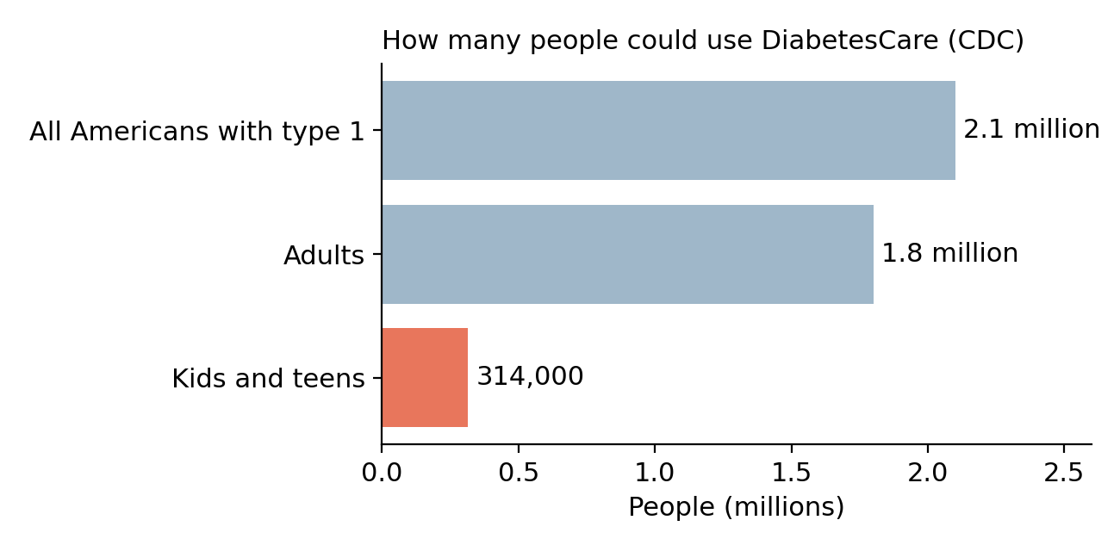
Figure 1. How many Americans have type 1 diabetes. Source: CDC National Diabetes Statistics Report.
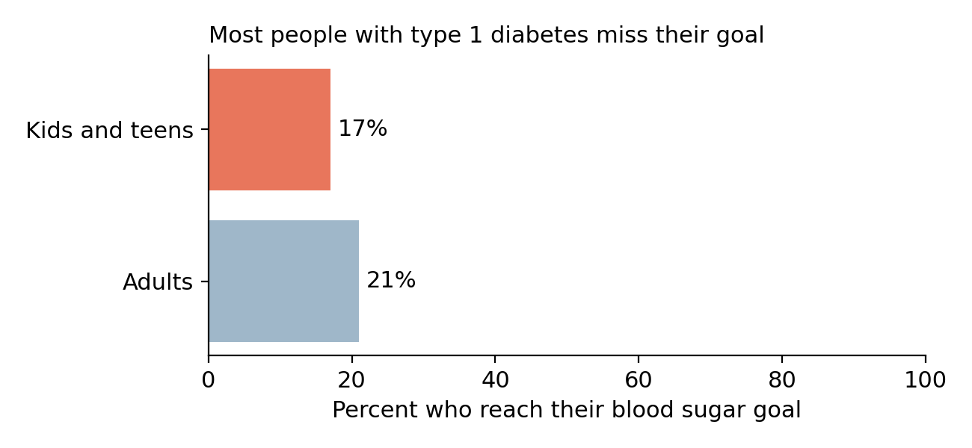
Figure 2. Only about 1 in 5 people with type 1 diabetes reach their blood sugar goal. Source: Foster et al., 2019.
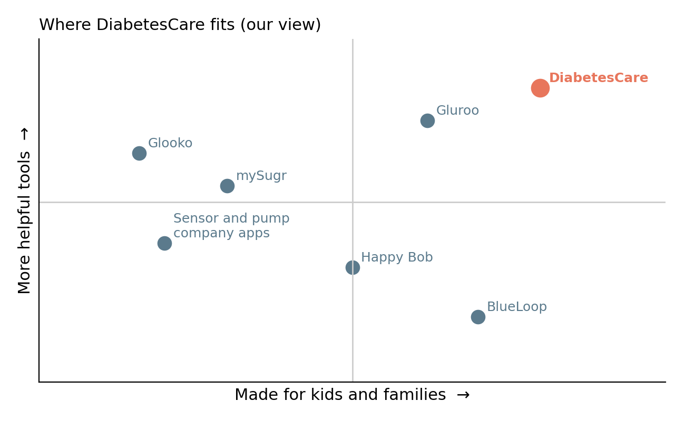
Figure 3. How we compare to other diabetes apps, based on our review of their features.
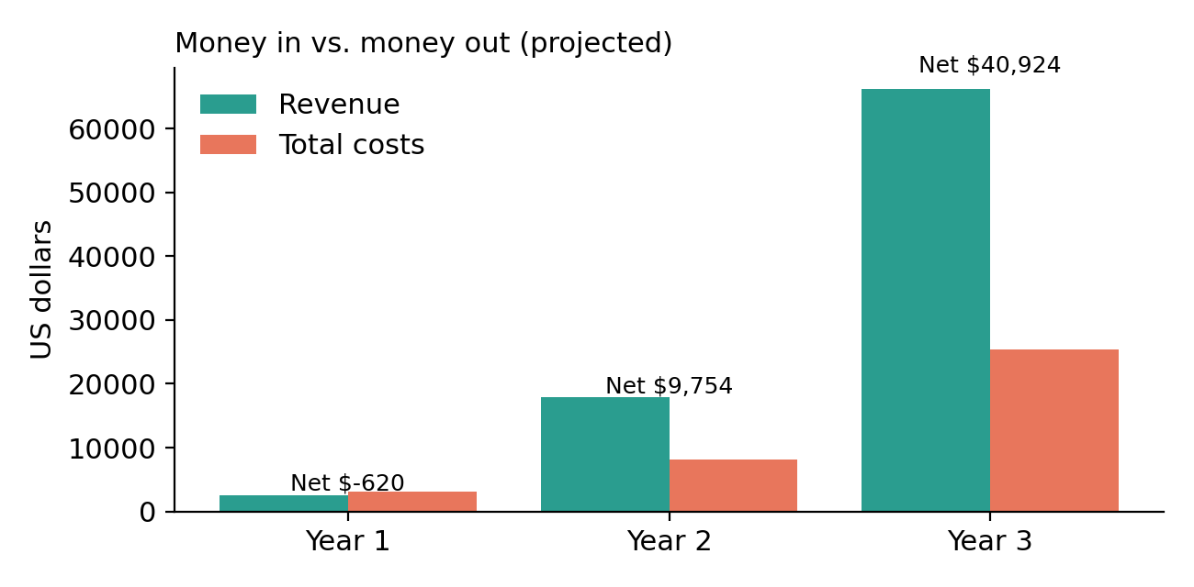
Figure 4. Projected sales vs. total costs over our first three years.
Pitch (3)
60-second pitch
"Picture a ten-year-old with type 1 diabetes. His body doesn't make insulin, so every day someone has to check his blood sugar and give him medicine. Right now that someone is his mom. She sets an alarm for 3 a.m. to check on him.
Five years later he's fifteen, and suddenly it's his job. That handoff is where things fall apart. Teens have the hardest time managing diabetes of any age group, and only 17 percent of kids reach their blood sugar goal.
The apps out there are either made for little kids or made for adults. None of them help a family through the handoff.
DiabetesCare does. When he's little, his parents are in charge. As a teen, he earns more control as he shows he can handle it. As an adult, he has everything he needs. It's the same app with the same history the whole way through.
We already have a working app. With about $2,800, we launch this November, reach 900 families by our second year, and start making a profit. We're Angad and Abhay, and we want to make growing up with diabetes a little easier."
Income statement (3)
Income Statement (projected) | Year 1 | Year 2 | Year 3
Sales (subscriptions) | $2,549 | $17,845 | $66,280
Minus Apple's 15% cut | -$382 | -$2,677 | -$9,942
Net sales | $2,167 | $15,168 | $56,338
Minus online storage costs | -$120 | -$600 | -$2,000
Gross profit | $2,047 | $14,568 | $54,338
Marketing and ads | -$750 | -$3,000 | -$8,000
Design and art | -$350 | -$500 | -$3,000
Legal and privacy | -$600 | -$300 | -$500
Diabetes nurse advisor | -$400 | -$400 | -$800
Apple account and website name | -$114 | -$114 | -$114
Equipment | -$200 | $0 | $0
Other and cushion | -$253 | -$500 | -$1,000
Total operating expenses | -$2,667 | -$4,814 | -$13,414
Net income (loss) | -$620 | $9,754 | $40,924
Notes: We are students and don't pay ourselves, so there are no salaries. Our startup money covers the small Year 1 loss. All numbers are estimates based on the assumptions in Revenue projection.
Sources
- CDC. National Diabetes Statistics Report. cdc.gov/diabetes/php/data-research
- Foster NC et al. State of Type 1 Diabetes Management and Outcomes from the T1D Exchange in 2016-2018. Diabetes Technology & Therapeutics, 2019. doi:10.1089/dia.2018.0384
- Hart RI et al. Parents' experiences of using remote monitoring technology to manage type 1 diabetes in very young children. Diabetic Medicine, 2022. doi:10.1111/dme.14828
- FDA. Examples of Software Functions for Which the FDA Will Exercise Enforcement Discretion. fda.gov
- FTC. Children's Online Privacy Protection Rule, 2025 update. ftc.gov
- Beyond Type 1. Money-Saving Tips for Diabetes Apps & Programs (mySugr pricing). beyondtype1.org
- Apple App Store listing for Gluroo; Apple App Store Small Business Program. apple.com
- Gluroo. Best Diabetes Apps For Children. diaTribe. 5 Diabetes Apps and Games for Kids.

